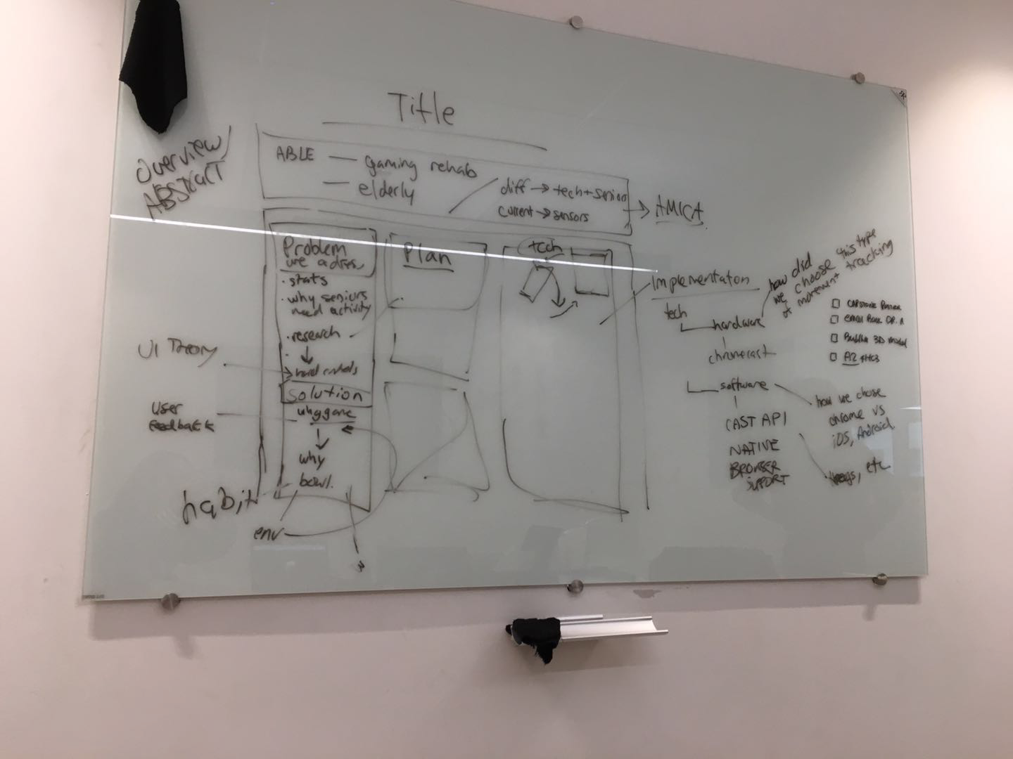

## ABLE ALLEY

## Overview

* What’s ABLE project
  + Gaming rehabilitation
  + Elderly
  + Current set up for ABLE (sensors n shit)
* Difficulties → Senior + Tech
* We will mention AMICA along the way

TEXT:

The ABLE project focuses on creating an art-based rehabilitation experience suitable for seniors. The goal is to provide an enjoyable experience for those undergoing at-home physiotherapy with the considerations of the elderly (dementia, fragility, memory). ABLE currently has development of gesture-tracking experiences that use sensor data from the user to make calculations and present the visual content. Some of the ongoing difficulties surround elderly are their comfortability and understanding of technology.[1] The ABLE Project is made possible by McMaster Humanities Department ( Pulse Lab) supervised by Dr. Paula Gardner as well as CAS faculty member Dr. Rong Zheng.

## Problem & Solution

* Problem
  + Stats
    - In canada, falling is the most common injury among elders
    - Every year, 1 in 3 Canadian seniors above the age of 65 will probably fall at least once

<https://www150.statcan.gc.ca/n1/pub/82-624-x/2014001/article/14010-eng.htm#a2>



* + - <https://www.canada.ca/en/public-health/services/health-promotion/aging-seniors/publications/publications-general-public/seniors-falls-canada-second-report/seniors-falls-canada-infographic.html>
  + Why seniors need activity
    - Fear of falling will cause senior to reduce their activities which will further increase the risks of the fall. Falling will also increase the fear of falling. Staying active will reduce the risk of falling.

<https://www150.statcan.gc.ca/n1/pub/82-624-x/2014001/article/14010-eng.htm#a2>

* + Research
  + UI Theory + Hard/Soft controls

TEXT:

With the baby boomers nearing the point of requiring extended care, the problems and concerns of the elderly are quite substantial. The effects of their healthcare is changing the Canadian economy and job markets. It is reported that it costs the government a hefty 2 billion dollars every year <statistics canada> just for healthcare associated with falls and slips.<someone mention the apple watch newest feature for watches that alerts of falls and slips> Loss of mobility (ending in falling/slipping) is so frequently occuring, in just one year 1 in 3 Canadian seniors above the age of 65 will likely fall at least once <statistic canada>, that the fear of falling alone can have a sizeable impact. The fear of falling can be so serious that seniors reduce their activities which can further increase the risks of a fall <statistic canada>. The elderly population needs to be able to exercise and stay active regularly in order to maintain their mobility. The problem is complex because the current elderly generation is not native to technology and therefore solutions that are too heavily technology-based will not be easily adopted.

* Solution
  + Why gaming
    - From previous ABLE project research, seniors don’t want to do actions on a screen (skip a rock) with absolutely no goal in mind or storyline. Therefore we have to pick a game that they are familiar with and fits the environment in the senior homes
    - Seniors feel more motivated and have more fun playing with Wii Fit® compared to regular exercises[2].
    - Learning and interacting with technology allows seniors to connect to the current world, interact with their grandchildren, and bond with other seniors[3].
    - Seniors realize they are capable of performing activities which they previously thought were impossible due to their age and well-being[3].
    - Games for Seniors need to take into consideration Seniors’ accessibility and guiding them through instructions as they are unfamiliar with modern technology[4].

[1]Theng, Yin-Leng, et al. "An exploratory study on senior citizens' perceptions of the Nintendo Wii: the case of Singapore." Proceedings of the 3rd international convention on rehabilitation engineering & assistive technology. ACM, 2009.

[2]Toulotte, Claire, Cindy Toursel, and Nicolas Olivier. "Wii Fit® training vs. Adapted Physical Activities: which one is the most appropriate to improve the balance of independent senior subjects? A randomized controlled study." *Clinical rehabilitation* 26.9 (2012): 827-835.

[3]Wollersheim, Dennis, et al. "Physical and psychosocial effects of Wii video game use among older women." *International Journal of Emerging Technologies and Society* 8.2 (2010): 85-98.

[4]Gerling, Kathrin, et al. "Full-body motion-based game interaction for older adults." *Proceedings of the SIGCHI Conference on Human Factors in Computing Systems*. ACM, 2012.

* + Why bowling
    - Golfing and bowling are the two options which seniors will be familiar with. Based on our research, both of them are physically suitable for seniors [1][2].
    - However, playing golf among seniors can promote negative mood disturbance, because golf is more competition based game [3]. The difference between golf and bowling is that bowling can be a cooperative game as well.
    - With bowling there can be a team score, we are planning to allow players to either play against each other or play with other teams. Also, with the nature of bowling, there will be a lot of room for interaction between the team as each player takes turn.
    - Bowling takes into consideration of senior accessibilities. Seniors with assistive devices such as canes and wheelchair will also be able to participate.
    - The exercises performed by the seniors will not be too strenuous while still providing exercises to improve/maintain their health condition.

1. <https://www.oatext.com/The-effects-of-Wii-bowling-on-balance-in-older-adults.php>
2. <https://www.tandfonline.com/doi/abs/10.1080/11038128.2016.1267259>
3. <https://www-ncbi-nlm-nih-gov.libaccess.lib.mcmaster.ca/pmc/articles/PMC3880083/>
   * Env setup
     + Setup with a mobile phone and a Chromecast on the TV in the common room of the senior home
   * Get some user feedback from Stephen
   * Habit formation [1]
     + Habit formation is an important part of behavior change interventions.
     + Connect the new behavior with an existing routine and turn it into an event-based task.
     + Use reminders to reinforce implementation intentions.
     + Avoid features that teach users to rely on technology.

<https://dl.acm.org/citation.cfm?id=2702230>

TEXT:

The foundations of the ABLE Project expose the success of gamified experiences with seniors and their exercise (in their case rehabilitation-based exercises). The ABLE Alley solution proposed is designed to compliment the project by creating a platform that supports exercises preventing loss of mobility, dexterity and stability. Previous feedback from the user study for ABLE’s sensor-driven experience is that seniors do not particularly enjoy engaging in activities digitally (e.g. skipping a rock) with absolutely no goal or storyline. ABLE Alley strives to create a gamified experience that is familiar to the users and contributes to an active lifestyle. ABLE Project has invested interest from AMICA (senior residence) for creating a platform that encourages social interaction as well as physical wellbeing. When creating content for elderly, it is important to keep familiarity in mind, more importantly habituation. When the users differ vastly in physical and mental ability, it is important to consider creating a game that can be understood and played by the majority. Habits that are formed get coded into the layers of the Brain, meaning that a person affected with memory loss might not be able to remember that they know how to do a particular thing however, they are still capable of creating new habits (such as how to play this game). For those with good memory, the benefits of a familiar setting is that Brain has less of a workload while engaging in this activity and the user can get all the physical benefits <REFERENCE: **The Power of Habits** - Charles Duhigg>. Considerations for physical ability are all together more complex because humans (and more so, elderly) come in a plethora of shapes and sizes with even more varying abilities. The elderly specifically bring more complications as they are often aided with peripherals such as wheelchairs, walkers, canes, etc. In order to be able to reach the most users, ABLE Alley is going to create a gamified experience that captures motion data without lower body mobility.

How to pick a game?

Research confirms that tennis, golfing and bowling are all suitable for seniors to maintain a good level of gait and balance <<https://www.tandfonline.com/doi/abs/10.1080/11038128.2016.1267259> and <https://www.oatext.com/The-effects-of-Wii-bowling-on-balance-in-older-adults.php>>. Luckily, most of the seniors should also be able to participate in any of these three common activities without much struggle.

However, tennis typically requires only two players, resulting in an absent of the team environment, losing the focus on the social aspect of the exercise. Golfing and bowling, on the other hand, are more desirable to create a fun group environment. However, research found that playing golf among seniors can promote negative mood disturbance as a side effect of the competitive nature of the game <<https://www-ncbi-nlm-nih-gov.libaccess.lib.mcmaster.ca/pmc/articles/PMC3880083/>>, while for bowling, seniors are encouraged to engage as a team and socialize with the other players while the active player is performing the action. This fits perfectly with the setup in most of the senior homes where common rooms are presented for residents to visit. On top of that, ABLE Alley proposes two different modes of the game, allowing players to either play against each other or play against other teams. Making it possible for the seniors to virtually interact with other people from other locations to create a sense of community.

Moreover, a higher level of the lower body mobility is required for tennis and golfing. In contrast, bowling takes senior accessibilities into consideration allowing seniors with assistive devices (canes, wheelchairs, etc.) to participate. Furthermore, gestures performed during bowling are not too strenuous while still offering a good chance for the seniors to maintain their health condition.

## Plan

## Technologies & Implementation

* Hardware
  + Chromecast

What you need:

* + - Chromecast
    - Chromecast technology allows your television to be controlled by other mobile devices on the same WiFi network. This means that WiFi is a must to have in order to use a Chromecast.
    - Affordable ($35)

<https://store.google.com/product/chromecast>

* + Phone (why not wii?)
    - Nintendo Wii
      * Complicated to create our own game. Nintendo is not into developer games and mods, no APIs
      * Expensive. Wii Console: $80. Wii Controller: $32 per controller per person
    - Phones, iPod Touch (any wifi device running Chrome)
      * Very common device
      * Affordable (from $100)
    - Motion recognition possible through 3-axis accelerometer sensor (X-axis (lateral), Y-axis (longitudinal), and Z-axis (vertical). ) by measuring the linear acceleration and the force of gravity.
      * Dynamic measurement can be calculated by combining the acceleration and gravity component.
      * As the magnitude and direction of acceleration can be calculated, various motions can be detected
      * The direction of the weight change reveals the orientation of the mobile device
      * The motions in the bowling game can be recognized by:
        + Quantifying the number of motions (may have to calibrate for different users)
        + To recognize specific motions, use a recognition mechanism to match the 3-axis accelerometer value to distinguished patterns of the motion.

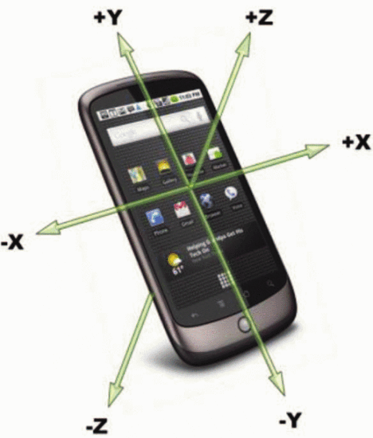

* + - <https://ieeexplore.ieee.org/document/6377845>
  + How did we choose this type of movement tracking
    - Movement sensing is done through the browser of the mobile device. The newer versions of Chrome will work better for the game. Not operating system dependent [1].

<https://developers.google.com/web/fundamentals/native-hardware/device-orientation/>

* Software
  + Why web vs iOS/Android
    - Cross-platform
    - All three of them have Google API support for Chromecast development
    - Need to develop two versions of game for iOS and Android
    - Web browser development can run on both platform, as long as Chrome is installed
  + Cast API
    - Full support from Chrome Sender/Receiver API [1]

<https://developers.google.com/cast/docs/developers>

TEXT:

Investigation of Technologies

For the ABLE Alley project, it was essential to find technology capable of providing movement inputs. Strong considerations of the elderly were applied when choosing technology however it is necessary to reiterate that since this generation of elderly are not native to technology (and that is to say not comfortable with technology), there will be a learning curve. Outlined below are the technologies investigated and how they compare given the considerations of the elderly (physical ability, etc) and the environment (similar to AMICA). Lastly the hardware and software of the chosen technology (Chromecast) will be defined.

|  |  |  |
| --- | --- | --- |
| Adopted | Technology | Analysis |
| X | Wii | The Wii is an excellent tool for receiving complex movement data since it involves communication between the controller and the sensor (and is therefore mostly unaffected by environmental factor). Nintendo can be praised for the addition of their physical cases which blur the lines between hard and soft controls (see wheel and racket controller casings) and could be beneficial for ABLE Alley (seniors would be interacting in a way they are familiar, with a controller that really resembles a tennis ‘racket’ or other peripheral). The downfall is that Wii is an expensive choice ( Wii Console: $80. Wii Controller: $32) with limited development capabilities (no APIs, no developer community). Each individual playing would need a remote (limiting to 4 players in a game) even if the game is turn-based. |
| X | Computer Vision | Working with Computer Vision can be extremely effective for applications that involve full body movement because properly trained, it can provide in depth information. There is virtually no limitations for types of experiences that can be provided for the user since practically any movement can be sensed and therefore interpreted. Another benefit is that there would be the potential to remove the physical technology from the user (once game is in progress). Computer Vision is not an ideal choice for this platform because ABLE Alley has no control over the environment (how big the room is, the depth of the room, etc). It would involve some training of the device in the designated location of use which limits the scalability of this project. Furthermore, with physical ability in mind, training a model to recognize all types of assisted walking devices/peripherals might not be possible. |
| YES | Chromecast | Chromecast is Google’s brand of casting technology which offers a way to create a connection between two applications (referred to as sender and receiver). Usually a casting session mirrors content from sender to the receiver while offering controls on the sender (similar to a remote and a television). Chromecast is considered for the project specifically using a phone for the sender application. While this is also an expensive option (requires phone, chromecast, wifi, tv), it is by far the most practical option for a few reasons. Firstly, it does not need to be a phone, simply a handheld device with access to Chrome browser and wifi will do (iPod Touch, etc). Restaurants, stores and other establishments have adapted to using handheld devices which is why it is safe to assume an establishment would be willing to purchase a few for their clients. Secondly, the Chromecast itself is not very expensive (and comes built into some televisions currently) sitting at approximately 40 dollars. Also, it is safe to assume that wifi is an acceptable prerequisite due to its availability in most other shared spaces. A limitations of the Chromecast/Mobile is only sensing data from the phone (limited to the actions perceived by the Chrome Browser on mobile) and relying on support for older browsers (movement sensing is done through the browser of the mobile device. The newer versions of Chrome might work better for the game. <Google Developers>) |

Physical sensors are not considered for this project because the ABLE Project is in progress developing with sensors and curating sensor data to get insights. The intention is to mirror their project goals with a practical solution for group gaming.

Building with Chromecast

Hardware: Chromecast v2, Phone (OS independent), TV + Router (wifi setup)

Software: HTML, CSS, JS (Three.js, Google Poly).

Motion Detection with Chromecast

Being able to receive motion data in critical to the logic propelling the receiver application.

* + - Motion recognition possible through 3-axis accelerometer sensor (X-axis (lateral), Y-axis (longitudinal), and Z-axis (vertical). ) by measuring the linear acceleration and the force of gravity.
      * Dynamic measurement can be calculated by combining the acceleration and gravity component.
      * As the magnitude and direction of acceleration can be calculated, various motions can be detected
      * The direction of the weight change reveals the orientation of the mobile device
      * The motions in the bowling game can be recognized by:
        + Quantifying the number of motions (may have to calibrate for different users)
        + To recognize specific motions, use a recognition mechanism to match the 3-axis accelerometer value to distinguished patterns of the motion.

